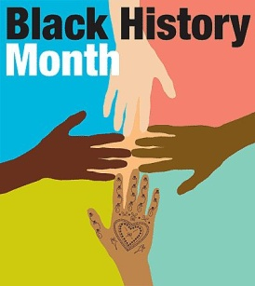
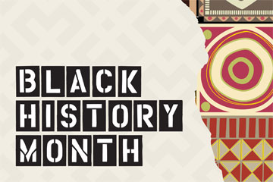
PLEASE CIRCLE THE CORRECT ANSWER

1. WHO WAS BRITAIN’S FIRST BLACK GOALKEEPER?
A. WALTER TULL
B. CLYDE BEST
C. ARTHUR WHARTON
D. DAVID JAMES

2. WHO DEFEATED LENNOX LEWIS IN SOUTH AFRICA 2001?
A. FRANK BRUNO
B. HASIM RAHMAN
C. EVANDER HOLYFIELD
D. FRANK WARREN

3. WHO WAS THE SECOND BLACK WOMAN TO WIN AN ACTING
OSCAR?
A. ANGELA BASSETT
B. JADA PINKETT-SMITH
C. HALE BERRY
D. ANGELA GRIFFITHS

4. WHO IS THE PREACHER?
A. COLIN POWELL
B. JOHNNIE COCHRAN
C. JESSE JACKSON
D. WESLEY SNIPES

5. COMEDIAN LENNY HENRY IS FROM?
A. LIVERPOOL
B. MANCHESTER
C. LONDON
D. BIRMINGHAM

6. WHICH OF THE FOLLOWING IS A JAMAICAN NATIONAL HERO?
A. PAUL BOGLE
B. SHABBA RANKS
C. BUJU BANTON
D. BOB MARLEY

7. WHO IS THE UK’s FIRST BLACK FOOTBALLER?
A. CYRIL REGIS
B. ARTHUR WHARTON
C. PAUL INCE
D. LES FERDINAND

8. WHO WAS THE SECOND BLACK MALE TO WIN AN ACTING OSCAR?
A. SPIKE LEE
B. DENZEL WASHINGTON
C. MORGAN FREEMAN
D. BLAIR UNDERWOOD

9. WHO IS “THE GREATEST” BOXER?
A. GEORGE FORMAN
B. MIKE TYSON
C. LENNOX LEWIS
D. MUHAMMAD ALI

10. WHEN IS BLACK HISTORY MONTH IN THE U.K?
A. FEBRUARY
B. OCTOBER
C. DECEMBER
D. AUGUST

11. WHO KNEW BY AGE 10 THEY WANTED TO BE A REVOLUTIONARY?
A. BOB MARLEY
B. MARTIN LUTHER KING JR
C. TUPAC SHAKUR
D. NELSON MANDELA

12. WHO HIT 375, THE MOST INDIVIDUAL RUNS SCORED IN A
CRICKET TEST MATCH?
A. VIVIAN RICHARDS
B. BRIAN LARA
C. IAN BOTHAM
D. DAVID GOWER

13. THE FIRST AFRICAN SETTLERS IN BRITAIN WERE RECORDED IN?
A. 1AD
B. 2AD
C. 3AD
D. 1950

14. WHAT IS DUB MUSIC
A. INFERIOR LOW QUALITY MUSIC USING NATURAL SOUNDS
B. FREEFORM JAZZ PREDOMINATLY FEATURING A TRUMPET
C. BACKWARD BRAND OF BEER MADE FAMOUS BY FROGS IN A
T.V.AD
D. INSTRUMENTAL MUSIC SPICED UP WITH SPECIAL EFFECTS AND
VIBES

15. WHO INVENTED BOTH GAS MASK AND TRAFFIC SIGNALS?
A. ALEXANDER GRAHAM BELL
B. JAMES DYSON
C. MORGAN FREEMAN
D. GARRETT A MORGAN

16. IN WHICH YEAR WERE THE FIRST RACE RIOTS IN LIVERPOOL?
A. 1919
B. 1922
C. 1981
D. 1985

17. HOW WOULD MARTIN LUTHER KING JR DEAL WITH PHYSICAL
FORCE FROM RACISTS?
A. BY PROTESTING PEACEFULLY
B. WITH BRUTE FORCE
C. WITH A HEAVILY ARMED BLACK MILITIA
D. TURN THE OTHER CHECK

18. THE CHATTRI INDIAN WAR MEMORIAL IS LOCATED IN WHICH
CITY?
A. LONDON
B. LIVERPOOL
C. BRIGHTON
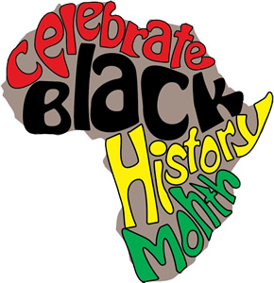
D. MANCHESTER

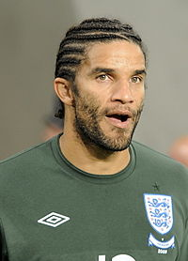

ANSWER SHEET

1. WHO WAS BRITAIN’S FIRST BLACK GOALKEEPER? D (DAVID JAMES)
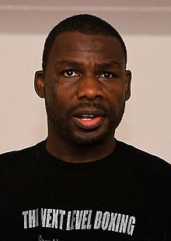

2. WHO DEFEATED LENNOX LEWIS IN SOUTH AFRICA 2001? B (HASIM RAHMAN)
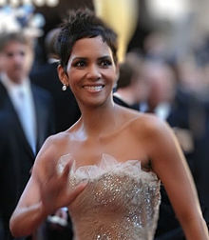

3. WHO WAS THE SECOND BLACK WOMAN TO WIN AN ACTING OSCAR? C (HALLE BERRY)
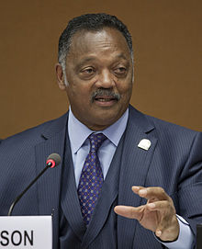

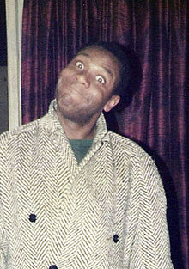
4. WHO IS THE PREACHER? C (JESSE JACKSON)

5. COMEDIAN LENNY HENRY IS FROM? D (BIRMINGHAM)

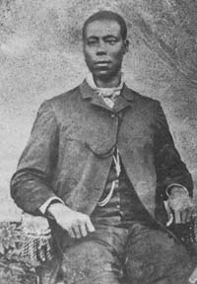

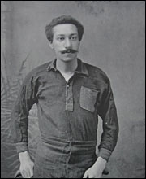
6. WHICH OF THE FOLLOWING IS A JAMAICAN NATIONAL HERO?
A (PAUL BOGLE)

7. WHO IS THE UK’s FIRST BLACK FOOTBALLER?
B (ARTHUR WHARTON)
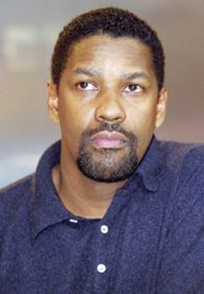

8. WHO WAS THE SECOND BLACK MALE TO WIN AN ACTING OSCAR?
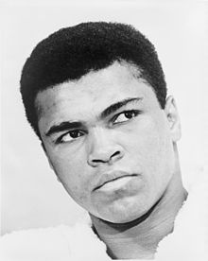
B (DENZEL WASHINGTON)

9. WHO IS “THE GREATEST” BOXER? D (MUHAMMAD ALI)

10. WHEN IS BLACK HISTORY MONTH IN THE U.K? B (OCTOBER)
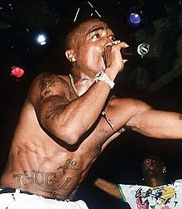

11. WHO KNEW BY AGE 10 THEY WANTED TO BE A REVOLUTIONARY? C (TUPAC SHAKUR)
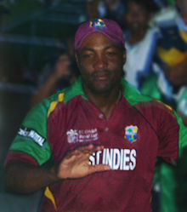

12. WHO HIT 375, THE MOST INDIVIDUAL RUNS SCORED IN A CRICKET TEST MATCH? B (BRIAN LARA)

13. THE FIRST AFRICAN SETTLERS IN BRITAIN WERE RECORDED IN? B (2AD)

14. WHAT IS DUB MUSIC D (INSTRUMENTAL MUSIC SPICED UP WITH SPECIAL EFFECTS & VIBES)
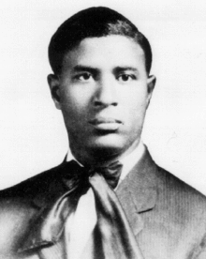

15. WHO INVENTED BOTH GAS MASK AND TRAFFIC SIGNALS? D (GARRETT A MORGAN)

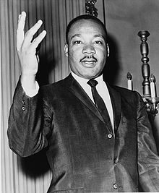
16. IN WHICH YEAR WERE THE FIRST RACE RIOTS IN LIVERPOOL? A (1919)

17. HOW WOULD MARTIN LUTHER KING JR DEAL WITH
PHYSICAL FORCE FROM RACISTS?
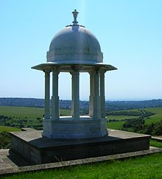
A (BY PROTESTING PEACEFULLY)

18. THE CHATTRI INDIAN WAR MEMORIAL IS LOCATED IN WHICH CITY? C (BRIGHTON)

