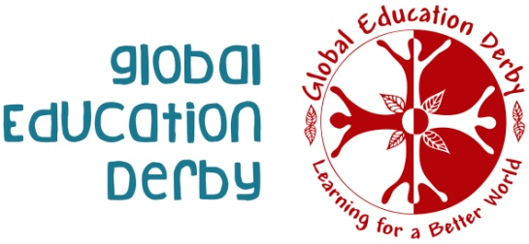**Global Quiz**

**How much do you really know about the world?**

|  |  |  |
| --- | --- | --- |
|  |  | **Answer** |
| 1) | In which country would you find the most southern city in the world? |  |
| 2) | How many bananas do we eat in the UK every year?  a) Roughly 5 million  b) Roughly 50 million  c) Roughly 5 billion |  |
| 3) | What percentage of people in the world are able to read and write? |  |
| 4) | Argentina gets its name from the Latin word, argentum. What does this word mean in English? |  |
| 5) | The capital of Brazil is:  a) Rio de Janeiro  b) Brasilia  c) Bogotá |  |
| 6) | Kiwi fruits are very high in vitamin C and best eaten raw – but do you know where most of the kiwi fruit we eat in the UK comes from? |  |
| 7) | How many time zones does Mexico have?  2, 4 or 6? |  |
| 8) | Which country is home to the Great Pyramid of Giza? |  |
| 9) | What percentage of the world’s population have access to the internet? |  |
| 10) | What percentage of the world’s population own a mobile ‘phone? |  |
|  |  | **Answer** |
| 11) | What is the official language of Senegal?  Image result for Senegal |  |
| 12) | What do the following countries have in common?  Ecuador, Brazil, Kenya and Indonesia |  |
| 13) | The Andes run through Peru and it is the highest mountain range in the world.  True or False? |  |
| 14) | In which country is the first Fairtrade certified Argan Oil cooperative in the world? |  |
| 15) | Brazil is the largest country in the world.  True or False? |  |
| 16) | Dates are grown on:  a) Fir trees  b) Palm trees  c) Cacti  Image result for dates |  |
| 17) | Montevideo is the capital of which country? |  |
| 18) | Do you know which area of Pakistan is well-known for making footballs? |  |
| 19) | Which country in Europe accepts the most refugees? |  |
| 20) | What does “Think Global, Act Local” mean? |  |

*Most questions adapted from:* [*https://schools.fairtrade.org.uk/resource/world-cup-quiz*](https://schools.fairtrade.org.uk/resource/world-cup-quiz)

Global Education Derby is a Registered Charity No. 1049591 and a Company Limited by Guarantee registered in England & Wales No. 2642026

Registered office address: 1st floor, 32 Charnwood St, Derby, DE1 2GU

[www.globaleducationderby.org.uk](http://www.globaleducationderby.org.uk)